# 

# Artificial intelligence version 1.2

Members of project:

Guolin Yang, Dexter Shepherd, Josh Hassett, Morgan Pile

Paper by:

Dexter Shepherd

# Planning and Design

## Task

To develop a system which uses the principle of the last version with certain additions. These additions will consist of the ability to output not only audio but physically through servos, same with learning through them. The system must be able to display a TFT with a face instead of an LED matrix, this TFT must be touchscreen so it can add certain options to the AI. The AI will have no need to remove any SD card as everything is added using the TFT.

This system will also be clearing up the bug from the last where the voice command would get the wrong sentences.

## Requirement

To get input from the user users voice, the system will find the sentence exact from the data, if nothing matches then it uses the RAW_WORDS function, which gets each word as itself.

If the sentence matches it looks in the data, normal words are outputted, certain symbol trigger the logic function in the code which sends commands to the servo board.

If the sentence does not match anything in the data, it will give you the option to “do command” or “say command”. These two options will define whether you use the servos or the voice.

The system on its TFT will show an eye and change dependant on the mood but if it is pressed it will lead onto the menu. The menu lets you write I WIFI specs, add phrases for the system to find in strings. The TFT also lets you add words for the MOVI voice shield to understand.

## User Interface

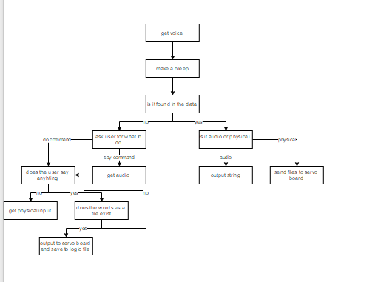

## Success Criteria

I will know the system works when it:

* Gets voice input
* can search for an output
* can output through audio
* can output through servos
* can add words to the MOVI through the TFT
* can add phrases
* can search the web for answers to questions
* can learn through physical input
* can use physical output while learning

## Test plan

|  |  |  |
| --- | --- | --- |
| Test Number | Test | Expected result |
| 1 | Does it get voice command, for example you say “how are you” | It proceeds and sends the words to be displayed on the TFT. |
| 2 | If it is in the data does it output if it is audio input | Outputs the string. |
| 3 | If it is in the data does it output if it is servo data | Opens up logic file and sends commands to servo board. |
| 4 | If the data is unknown, it asks options | Outputs “would you like me to say or do a command?”. |
| 5 | Gets input from the user | Will tell you what option you said. |
| 6 | Does it take in physical input | Will replay the movement you inputted in. |
| 7 | Does it do and save previous commands while in data | If you say an existing command it will output the command and save it to the data. |
| 8 | Does the data save | If you say the command it will output. |
| 9 | Does the system add words | When you type it in and switch the system on and off again, it will say it is adding new sentences. |
| 10 | Does the TFT use touchscreen correctly | When you click the option buttons it takes you t new pages. |
| 11 | Does it add phrases | When you say a sentence with a phrase in it will hijack the sentence and make it do your choice. |
| 12 | Does it search the internet | When you chose options to search it will output an answer. |
| 13 | Does it accept the Wi-Fi passwords | Show a green led on the Wi-Fi board |
| 14 | Does the main board and servo board simultaneously create and save files when adding an action? | A file with the number of the command is created on the SD cards. |
| 15 | Does a tft screen work (change picture when commanded. | Yes, faces or menus appear when appropriate. |
| 16 | Does the system output previously learn physical commands? |  |
| 17 | Does the system add physical command files to a physical file in the making when commanded? |  |
| 18 | Does the system prevent overload by cutting off the ability to add files which have included files in. | When you try to it outputs “no such file”.  The system can only open one file at a time so this means if the system opens up files to read while in a file there shall be run time errors or logic errors. |

## Variable Plan

## Hardware

Arduino mega x 3 (one for main board, one for servo board and one for TFT)

Arduino Uno x (WIFI)

SD card holder x 2

SD card x3 (2 normal, 1 micro)

LEDs

TFT touchscreen module

WIFI module

MOVI shield

Microphone

Speaker

## Flowchart

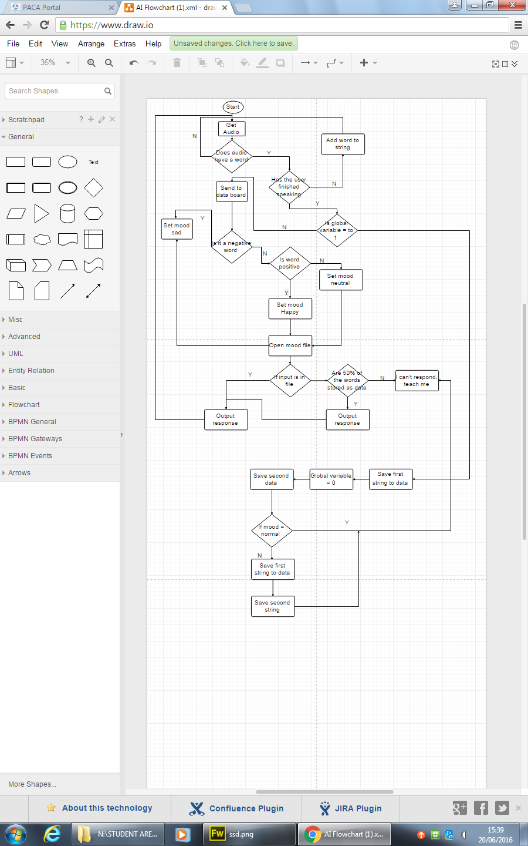

## Pseudocode

Main board

Function main ()

{

Voice ()

Check ()

Reset board

}

Function voice ()

{  
Get audio words ()

If (audio has found)

{

Bytes = audio

}

}

Function check ()

{

Loop

{

If word contains anything in sad vocab file

{

File = open sad file

}

Else if word contains anything in happy vocab file

{

File = open happy file

}

Else

{

File = open main file

}

Check through file to see if word string is inside

If true

{

Get known response

Say response

break

}

If over half the words are found in sentence

{

Find response

Say response

}

Else

{

Say “would you like to do or say command”

String1 = bytes

Voice ()

String2 = bytes

If (string2 = “say”)

{

Say “please say your sentence”

Voice ()

String2 = bytes

Write to data (string 1 + “*” + string2 + “/”)

} else if (string2 = “do”)

{

Say “do command”

Voice ()

String2 = bytes

If (string2 = “get”)

{

} else

{

Send command ‘@’ to servo board

Loop

{

Voice ()

String2 = bytes

If (string2 = “end”)

{

Output reset to servo baord

}

}

}

}

}

}

}

Servo board

Function main ()

{

If (globalVariable = 1)

{

All servos attach

Loop

{

Loop through data and read first series of positions

Write positions to servos

}

}else if (globalVariable = 2)

{

Loop ()

{

Get input from all potentiometers

Write them to current file

}

}

}

Function receive event ()

{

char x = read wire

String += x

If (x = /)

{  
 file = string + “.txt”

GlobalVariable = 1

} else if (x = @)

{

GlobalVariable = 2

}  
}

TFT board

Function main ()

{  
display current page

If (home button pressed)

{

Page = menu

} else if (WIFI button pressed)

{  
page = WIFI

} else if (phrase button pressed)

{

Page = phrase

} else if (words button pressed)

{  
page = words

} else if (face button pressed)

{

Page = mood

}

}

Function receive event ()

{  
x = read ()

If (x is a sentence)

{

TFT output sentence

}

If (x = s)

{

Mood = sad

} else if(x = h)

{

Mood = happy

} else

{

Mood = normal

}

}

WIFI board

Coded Solution

# 

# Development

## Development diary

|  |  |  |
| --- | --- | --- |
| Date | What I worked on | What happened / What testing |
| 25/09/2016 | I started to write the development paper. I have already previously worked on individual boards before planning it. These boards are the touchscreen and the servo output. |  |
| 01/10/2016 | Instead of have two circuit boards for the screen and main board I have incorporated it so the main board has the screen. This will save time, money and recourses. It also means that the screen board has more memory and processing power.  I came across a bug where the audio output can’t handle sentences which are ‘too long’ and instead say half of the output message.  I designed and printed a head for the AI but after waiting 11 hours for it to finish printing 4 am in the morning and ruining my sleeping pattern I decided to go for a different look.  Instead of designing product hardware before electronic hardware and fitting it in, I decided it would beneficial to design a frame to hold the circuits in the best operating way and fit hardware shells around. |  |
| 23/10/2016 | I have added potentiometer and button input instead of the touchscreen within these past few weeks. You can also use voice to navigate through the menu although there are a few bugs.  The system has the ability to add words to the known data via the screen while in program.  When adding commands to the memory it now gives you the choice to add an action or add speech. Speech works how the system has always worked. Action allows the user to physically input using potentiometers. So far I haven’t had a chance to test out the servo board code although I have managed to make the main board send commands to the servo board.  When I test the adding command function I hope to see the servo board get triggered and start saving potentiometer readings.  The main code allows the user to say previous commands and I am hoping to develop the ability to save them to a string which shall be saved to the new file. |  |
|  |  |  |
|  |  |  |
|  |  |  |
|  |  |  |

# Testing

## Test results

|  |  |  |  |
| --- | --- | --- | --- |
| Test number | Test | Pass/fail | Comment |
| 1 | Does it get voice command, for example you say “how are you” |  |  |
| 2 | If it is in the data does it output if it is audio input |  |  |
| 3 | If it is in the data does it output if it is servo data |  |  |
| 4 | If the data is unknown, it asks options |  |  |
| 5 | Gets input from the user |  |  |
| 6 | Does it take in physical input |  |  |
| 7 | Does it do and save previous commands while in data |  |  |
| 8 | Does the data save |  |  |
| 9 | Does the system add words |  |  |
| 10 | Does the TFT use touchscreen correctly |  |  |
| 11 | Does it add phrases |  |  |
| 12 | Does it search the internet |  |  |
| 13 | Does it accept the Wi-Fi passwords |  |  |
| 14 | Does the main board and servo board simultaneously create and save files when adding an action? |  |  |
| 15 | Does a tft screen work (change picture when commanded. |  |  |
| 16 | Does the system output previously learn physical commands? |  |  |
| 17 | Does the system add physical command files to a physical file in the making when commanded? |  |  |
| 18 | Does the system prevent overload by cutting off the ability to add files which have included files in. |  |  |

# Future ideas

Include many Arduinos that will connect to each other so they can have conversations. Have a system where the program will remember the last thing it said as a short term memory thing.

Another idea is that it will not only be able to learn how to respond through words but how to respond through physical interaction.

More ideas include object recognition and using its own 3d maps stored like a radar in arrays (X, Y, Z) to locate the object.

More ideas include using potentiometers to get servo input and output it when commanded, instead of the AI just learning verbal response, why can’t it use physical output, and potentially physical input.

Allow the AI to connect through the internet using WIFI shields or cheaper Ethernet shields. When the AI is asked a question it doesn’t know the answer to it will search the internet for an answer, if it cannot find one on the internet it will have to say; “sorry I do not know, maybe try research it when you have some free time”.

# Evaluation